1. 
2. 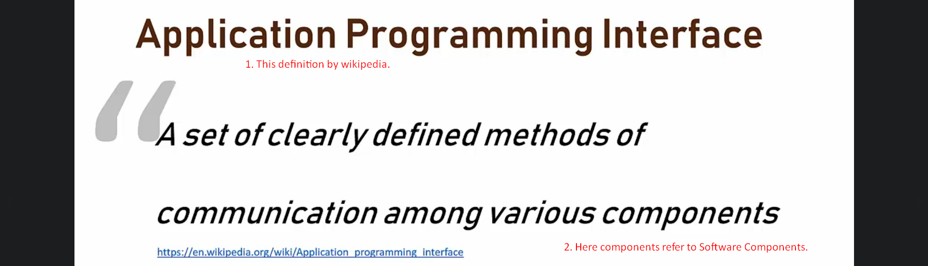
3. Let’s talk about the interface part the API (App Programming Interface)
4. User interface is what a user sees when the user looks at something. In case of website, it is probably the homepage of the website that you’re browsing to. **So interface is the part that is exposed to you**.